NOR’EASTER XXIX

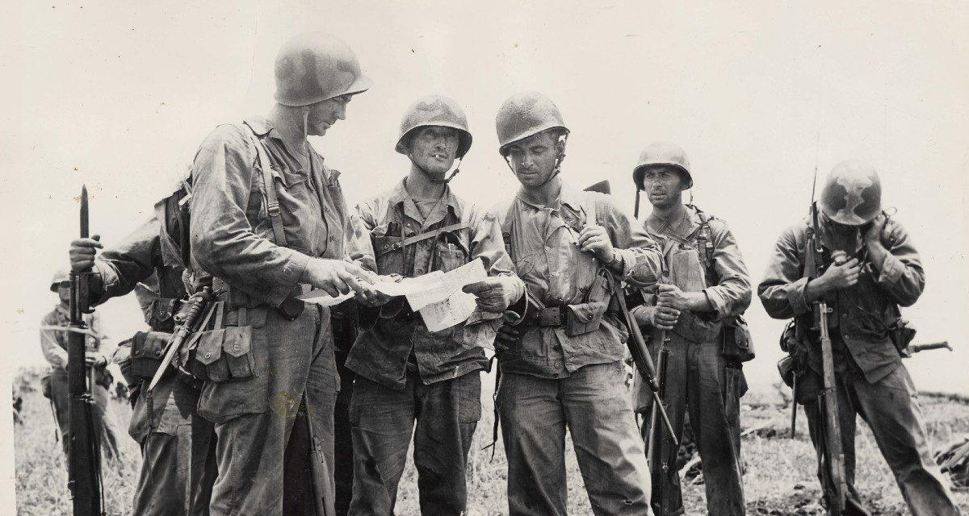

“More damned construction!”
Join us at the Nor’easter anyway!

March 27 - 30, 2025
Springfield, MA

Register at: https://asl.yankeegamers.org
Book Hotel at: La Quinta Inn by Wyndam Springfield MA

